EpitopePredictions vs MHCnuggets
How they work and how they differ.

Introduction
We have two programs (MHCnuggets and Epitope Predictions) which both predict how likely a certain epitope is to be shown on the outside of the cell membrane with different haplotypes. This is important in the recognition of one's own body cells. If a cell presents an epitope [RJCB: an epitope, by definition is recognized by the immune system] that is not recognised by the immune system, it will be killed, which is a good thing [RJCB: ‘good thing’ is subjective, use something more objective. Also, it is a ‘bad thing’ for the virus. Take an objective perspective], as the cell could be malfunctioning or infected by a virus. This presentation of epitopes also plays a key role in vaccine development. In order for a vaccine to be effective you want the epitopes to be presented as often and in as many cases as possible, therefore the vaccine has to contain epitopes for all immune types. Thus the immune system can quickly detect it and develop antibodies against the pathogen. Also, this can be used to make sure that this happens on every different haplotype, so people with different immune systems all get immune quickly. However, these programs output some very different results and thus it is unknown if the given predictions are trustworthy or not. In this paper we discuss the differences between these programs, why they are caused, and how this affects the usefulness of the results.

Hypothesis
Since both programs are trying to predict the same thing, we expected the results to be equal, or at least very similar [RJCB: define ‘similar’]. However, as will be shown in the results section of this paper, both programs output different [RJCB: define ‘different’] results. We suspected this could be caused by the use of different scales for both programs, just like thermometers can give temperature in celsius or fahrenheit [RJCB: this is no suspicion, this was likely from the start and well-known]. In this case the numbers differ, but the temperature stays the same. We thought the same might be happening here. If this is happening, we expect the highest results of EpitopePredictions to also be the highest result from MHCnuggets, and vice versa. [RJCB: this last line is great: it gives a clear expectation. Add the word ‘significant’ for some alpha value (usually 0.05)][RJCB: the hypotheses should correspond with the Methods. If you need a monotonous increase/decrease, assume it is present or absent, so there is the need for a statistical test]

Methods

Correlation
Here we will be showing our methods for determining whether or not there is a correlation between the predicted results from both programs. We demonstrate this using some examples.[RJCB: brilliant start!]

In this table we have the temperature in two different units: Celsius and Fahrenheit. If we were to plot this table, we would get the graph below. The x-axis shows the temperature in Celsius and the y-axis shows the temperature in Fahrenheit. In this example it is easy to see the correlation: as we increase the value of the x-axis, the y-axis follows. While such a correlation is easy to spot, it becomes more difficult when there is noise involved. For this example we expect a trendline with the following formula: Temperature (°F) = (Temperature(°C) × 9/5) + 32. If we look at the graph we see it starts at 32, which results in the +32. The slope of the graph is equal to , which corresponds to the expected slope.
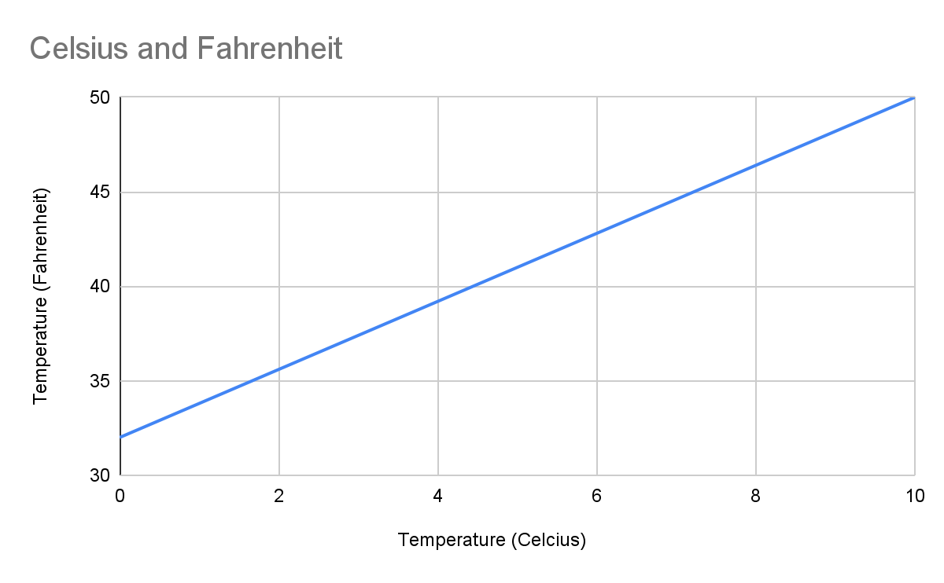
This example [RJCB: ‘the example below’ or put the figure before this paragraph] is exactly the same as the previous example, but we added some noise to the measurements. Though, at first glance, it might not seem like there is a clear correlation between the two, a trendline shows that this assumption is false. We still have the same correlation between the temperature in Celsius and the temperature in Fahrenheit. Here, the trendline has an equation of . This slope (1.7391) is very similar to the expected slope of
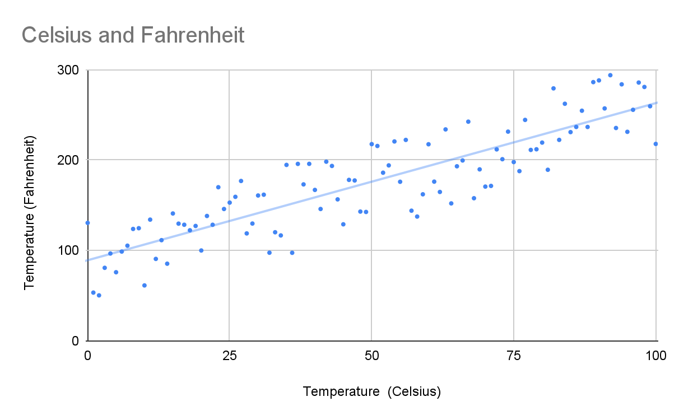
For our last example we have a graph with random data. Here we see there is no correlation: as we increase the value on the x-axis, the y-axis stays the same, this can be seen using the trendline, which has a equation of . This slope is very close to 0, indicating there is no correlation.

We also have a way to quantify this correlation, using the Pearson Correlation Coefficient. [RJCB: great! now do apply the PCC to the example data as well. This gives an idea how that statistic works]

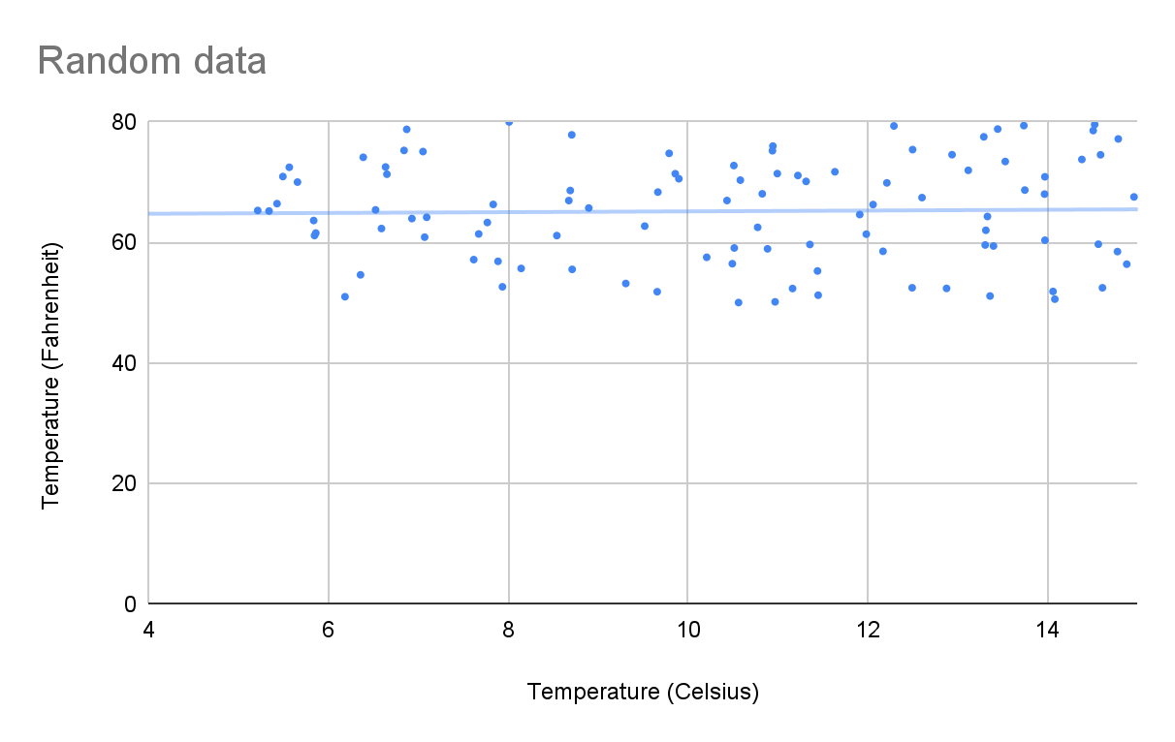
Pearson Correlation
Using the Pearson Correlation Coefficient we are able to find a correlation between the results of MHCnuggets and EpitopePredictions for each different haplotype. See the formula down below [RJCB: I enjoy the enthousiasm for the Equation Editor, but a picture from Wikipedia would work better for non-Windows users].

= correlation coefficient
= values of the x-variable in a sample
= mean of the values of the x-variable
= values of the y-variable in a sample
= mean of the values of the y-variable

[Formula explanation][RJCB: I don’t care about the details of this equation. I do care about what the value tells me and what range it has. Use the examples above to demonstrate]

Spearman Correlation
[RJCB: I enjoy this idea, except for how it is introduced. Start with connecting it to the PCC, e.g. ‘The PCC assumes that the data increases or decreases monotonically’] While it seems as if this coefficient could provide solid evidence as to whether there is a correlation or not, the Pearson correlation coefficient has some drawbacks. To illustrate this we use the following graph:
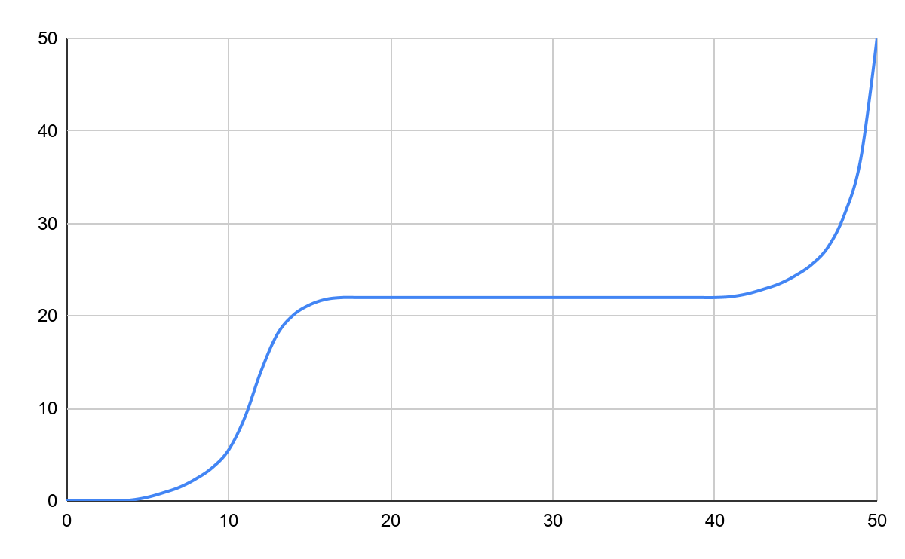
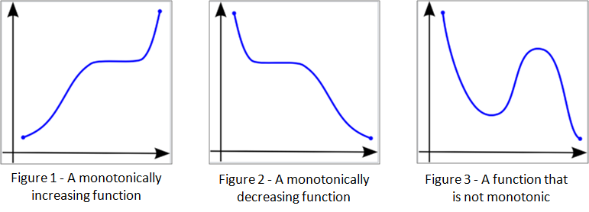
It is clear there is a correlation between the variables, but this correlation is non-linear. If we were to input these values into the Pearson formula, we get a correlation of 0.843, which is still considered quite strong, but the Pearson Correlation Coefficient is not meant to be used on a non-linear graph like this one. To work around this problem, we will also be testing if there is a non-linear correlation. For this we use the Spearman’s Correlation, which can be used to determine correlation between monotonic, or monotone, sets of data. Monotonic meaning they both tend to go up, or down, together.[RJCB: this is a great section and I love the figures. Add the Spearman values to the figures to demonstrate how the SC works]

This is where the Spearman Correlation comes into play. Using the following formula, we are able to determine how strong a monotonic increase or decrease is between the two datasets, if there is any.

r_{s} = correlation coefficient
N = the number of data points
D_{i} =
[Formula explanation][RJCB: also here, I don’t care much about the details of the equation. I do care about how the SC works, what the range of its values are, how to interpret a value]

When we input the same graph in the Spearman formula, we get a correlation of 0.9463 [RJCB: use correct amount of significant digits]. Which is very close to one, meaning there is a very strong correlation between the variables in the graph. If this graph were less perfect, and predictable, the Pearson Correlation could indicate there is no correlation, or a very weak one, while there may still be a monotonic relation present. That is why we will also be testing every haplotype to see the Spearman correlation, to determine if there is a monotonic relationship.

But this is not where it ends. As there are non-linear graphs that are not monotonic, like a parabola. For this type of correlation we will be plotting the haplotypes as well, to see if there is a different type of correlation visible.

Biology
Before we dive into the two models and the results it is first necessary to understand what kind of values these models actually predict and what those values mean in the physical world. Therefore we will dive into the biological side of EP and MCHn [‘MHCnuggets’].

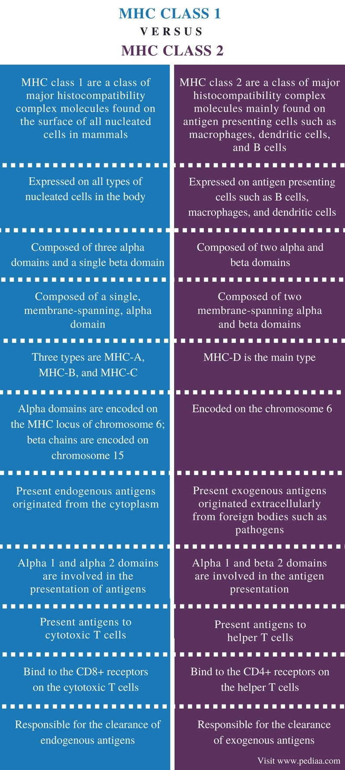
How are antigens presented to the immune system?
[RJCB: remove the picture. Either create your own table in your own language, or remove it altogether. AFAICS, this text is sufficient]The immune system determines whether a cell in the body is invasive, like a bacteria, and should thus be killed, or a body’s own cell, like a blood cell or a liver cell.
This is usually accomplished by checking whether the antigen that is presented on a MHC-I (Major Histocompatibility Complex) or a MHC-II molecule [RJCB: for this research, we care nothing about MHC-II. Sure, mention it briefly, e.g. ‘Where MHC-I is the main presenter molecules for viruses, MHC-II fulfills a similar role in clearing bacteria and fungi]. These two molecules have nearly the same name, but differ a fair amount. MHC-I molecules are found on the surfaces of all nucleated cells, cells with a nucleus. At that place they present epitopes found inside the cell itself. MHC-II molecules are only found on the surfaces of antigen presenting cells (APCs) like macrophages or phagocytes. Thus MHC-I is used for the detection of infected cells by, for example viruses and MHC-II is used for presenting the antigens of a virus or bacterium to other cells in the immune system, for example, T helper cells or B cells.^{[4]}
For viruses this can be determined by verifying the antigens on the virus’ viral envelope or when a certain cell is infected and is showing a foreign antigen on one of it’s MHC-I proteins. The viral envelope is a defensive shell to protect the DNA inside it.[] When, for example, a T_{c} cell detects one of those antigens [RJCB: add ‘as presented by MHC-I’] it will determine whether it is foreign or not, if that is the case the T_{c} cell will kill the [RJCB: add ‘infected’] cell by disintegrating it’s membrane with proteins. It will also start cloning itself rapidly to be able to more quickly notify other cells necessary in the defense against the virus like B-cells or macrophages.
For bacteria this process is fairly similar, the differences stem from the fact that usually a bacterium’s antigens aren’t directly presented on an infected cell’s membrane. But only on the Bacterium’s membrane, thus a T_{c} cell can’t detect (can bacteria be detected when they are inside of a cell?[RJCB: no. Especially in malaria this is a problem!]

How does IC₅₀ relate to this?
IC₅₀ (half maximal inhibitory concentration) is a biological unit that describes how much of a certain substance is required to inhibit, in vitro [RJCB: I think ‘in vivo’ and ‘in silico’ are just as relevant], a certain biological processor component by 50%. This could be, for example, a drug, enzyme or cell. The scale often used for expressing IC₅₀ values is molar concentration (mol/L).

In our case the IC₅₀ value corresponds with the amount of epitopes presented on a cell’s surface (?) [RJCB: the IC50 determines how well a peptide binds to MHC-I. A peptide with a low IC50 will ‘inhibit’ an MHC-I from any futher binding, as it itself occupied the binding cleft. Peptides with a low IC50 are thus likelier to be presented] that are needed to achieve 50%.

Epitope Predictions
Epitope Prediction is one of the programs used for the prediction of an IC₅₀-value. It was developed by Johannes Textor. Epitope Predictions uses a stabilized matrix [1] to calculate this IC-50 value.

Stabilized matrix
A stabilized matrix is [info]
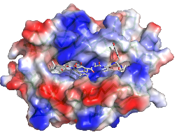
It uses the sum of the hydrophobicity value [2], the physical property of a molecule [the sum of one molecule is a bit dull I would say. Talk about amino acids in a peptide here :-)] that is seemingly repelled from a mass of water, of each of the amino acids to calculate how likely they are to appear on the cell membrane. This is where MHC class I is important. The MHC I molecule is built up of α- and β-chains [], which differ between haplotypes. These chains form a groove, in which a peptide can bind. The MHC I groove is closed and because of this mostly short epitopes can properly bind to it, though research has shown longer epitopes do sometimes bind to MHC I []. These epitopes are mostly between 9 and 11 amino acids long. However, epitopes with different lengths often use alternative binding grooves, which complicates predictions []. Because of this Epitope Predictions uses epitopes that are 9 amino acids long, because they are most common [3], and to simplify predictions.[RJCB: what is the relation between these predictions and reality? Same question I will ask for MHCnuggetsr]

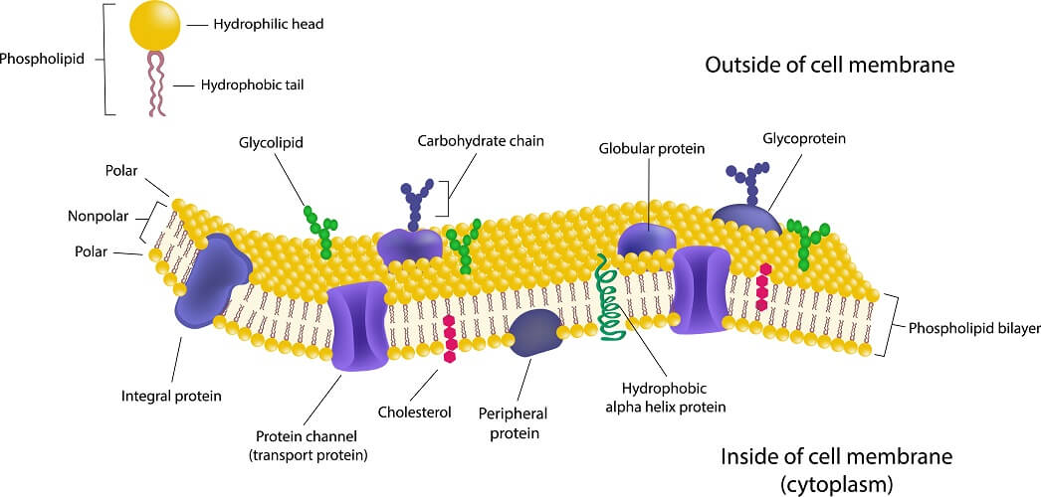

The membrane of a human cell is built up of phospholipids, which consist of a hydrophobic tail and a hydrophilic head. This means that a hydrophobic amino acid is less likely to appear on the outside of a cell membrane. See the image below.[RJCB: I enjoy a picture of a cell membrane, but it has nothing to do with EpitopePrediction, so maybe move or remove it :-)]

MHCnuggets
MHCnuggets is another program which predicts an IC₅₀-value. MHCnuggets is developed to to work around the limitations other predictors had, by using a neural network that predicts the peptide-MHC bindings. It uses a method called LSTM(long short-term memory) which is good at processing peptides which can be of any length. The neural network got trained [RJCB: on what?] with a method called transfer learning, which in this case means the network uses the data(binding affinity, IC50-value) from other alleles to predict the IC₅₀-value of an unknown (to the program) allele.[RJCB: what is the relation between these predictions and reality? Same question I will ask for EpitopePrediction]
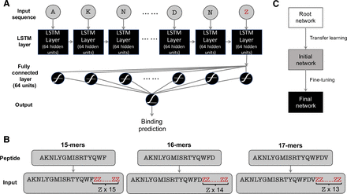
visualisation of the neural network [RJCB: add source. Tell what it shows. If it shows nothing relevant, remove it. But I think you want to keep this picture in for a good reason :-)]

R-code
The scripts that are used to generate the results can be found here. [RJCB: full URL please. You may paste the code in the Appendix (aka Supplementary Materials) as well] They roughly work as follows: the first script is used to generate random peptides (line 20 to 31) and after that the two programs MHCnuggets and EpitopePrediction are used to predict the ic50 values of the randomly generated peptides (line 33 to 41), these are stored in the file “ep_vs_mhcn.csv” (line 43) [RJCB: I care about what these programs do, not how they name their files. Focus on what is relevant to answer the research question].

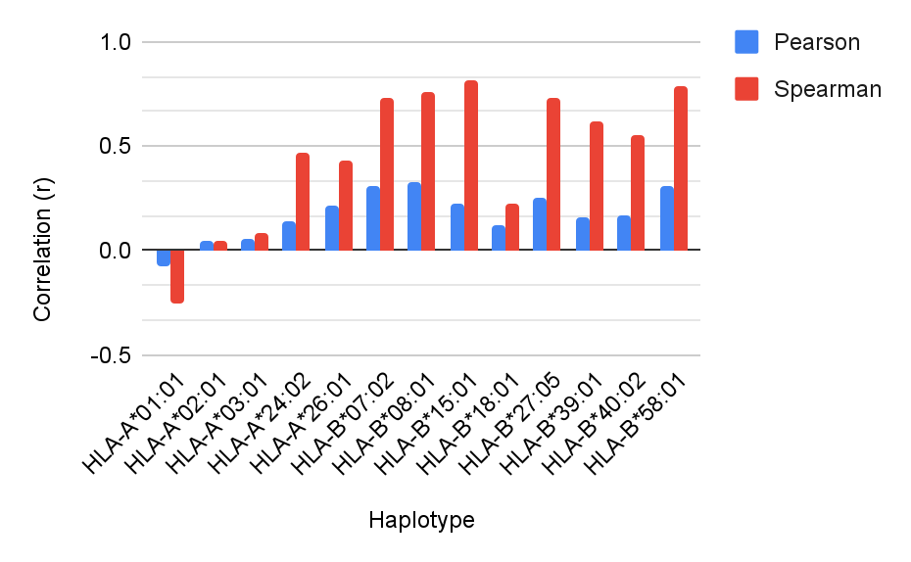
Results

Haplotype | Pearson Correlation | Spearman Correlation
HLA-A*01:01 | -0.074 | -0.251
HLA-A*02:01 | 0.042 | 0.043
HLA-A*03:01 | 0.055 | 0.08
HLA-A*24:02 | 0.138 | 0.469
HLA-A*26:01 | 0.218 | 0.434
HLA-B*07:02 | 0.309 | 0.734
HLA-B*08:01 | 0.329 | 0.762
HLA-B*15:01 | 0.227 | 0.812
HLA-B*18:01 | 0.119 | 0.221
HLA-B*27:05 | 0.252 | 0.73
HLA-B*39:01 | 0.156 | 0.623
HLA-B*40:02 | 0.171 | 0.556
HLA-B*58:01 | 0.31 | 0.785

Here we have the correlation-values as calculated using both Pearson’s and Spearman’s formulas. The Pearson Correlation gave a value between -0.074 and 0.309 and the Spearman Correlation ranged from -0.251 to 0.812. The first three values are very close together.
[RJCB: already here: can the PCCs be trusted based on the SCs?]
A notable exception is that the first haplotype has a slight negative correlation, contrary to all the others which have a slight or moderate positive correlation. This means that value B coming after value A has a lower value than A and with the others value B is higher than value A [RJCB: I feel the explaination only confused me. Point me to to a line in a figure or so :-)]. Another peculiarity is that the values calculated by Pearson’s coefficient are consequently lower than those calculated by Spearman’s coefficient [RJCB: that is not peculiar: those two values are completely unrelated]. However, in haplotype HLA-A*02:01 this is not the case, but the r values [What are r values?] for that haplotype are so low that this could easily be due to statistical errors, like a rounding error. [This indicates that the haplotypes are in a monotonic relationship, due to monotonic relationships always having linear parts that will be detected by Pearson’s coefficient. Spearman’s coefficient however, will detect the whole monotonic relationship instead of only it’s linear parts, therefore resulting in higher values for Spearman’s coefficient, but still moderate values for Pearson’s.](mogelijk naar conclusie) [RJCB: focus more on what is important, especially on which PCCs can be trusted and which one not, as this helps answer the hypothesis]

[RJCB: what does that figure from me do here? AFAICS, you don’t need it, so remove it, I won’t be offended :-)]

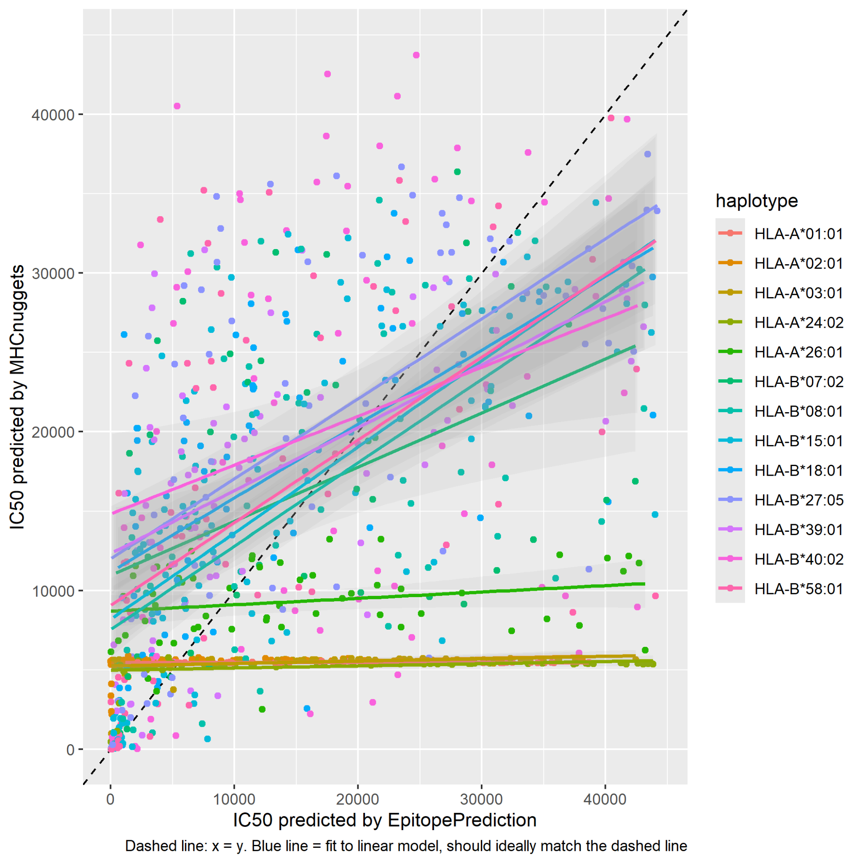
Conclusion
As can be seen in the results (figure x[RJCB: which figure?]), there appears to be a slight correlation according to Pearson’s coefficient (an average r-value of 0,1732). But this is not high enough to be considered statistically significant [RJCB: AFAICS, you don’t do statistics on that value. If no statistics, don’t use the word ‘significant’. Else I would enjoy the description of that test, and the p value], for that to be true the value has to be above 0,3, which is true for some haplotypes though. Indicates a slightly linear graph?
Interestingly, the average correlation calculated by Spearman’s coefficient is much higher, namely 0,4614. This can be considered as statistically significant. Indicates a fairly monotonic graph, thus the next point in this case usually has a higher value than the one before that. Not necessarily linear? And what does that mean exactly in this situation?
It can also be seen that the (trend)lines are very comparable. The differences in the y-values are often comparable, but the Pearson graph almost constantly has lower values, this might mean that the graph is partially linear and partially monotonic, more research has to be done to verify this? [RJCB: I miss a conclusion. Please conclude something based on your results]

Discussion
[RJCB: remove if you know not what to write there. I can live with that :-)]

Definitions

Epitope: the part of an antigen molecule to which an antibody attaches itself. An epitope is a specific protein on the surface of an antigen and is used for recognition of cells.

IC₅₀: a quantitative measure that indicates how much of a particular inhibitory substance (e.g. drug) is needed to inhibit, in vitro, a given biological process or biological component by 50%. The biological component could be an enzyme, cell, cell receptor or microorganism. For our research this means a lower IC₅₀ corresponds to an epitope beine more likely to be presented.

Haplotype: a group of genes within an organism that was inherited together from a single parent. A different haplotype can correspond to a different MHC I-complex, which in itself means that different epitopes are more or less likely to be presented to the immune system.

References
[1] Peters, Bjoern, and Alessandro Sette. "Generating quantitative models describing the sequence specificity of biological processes with the stabilized matrix method." BMC bioinformatics 6.1 (2005): 1-9.

[2] Sanchez-Trincado, Jose L., Marta Gomez-Perosanz, and Pedro A. Reche. "Fundamentals and methods for T-and B-cell epitope prediction." Journal of immunology research 2017 (2017).

[3] Trolle, Thomas, et al. "The length distribution of class I–restricted T cell epitopes is determined by both peptide supply and MHC allele–specific binding preference." The Journal of Immunology 196.4 (2016): 1480-1487.

[4] Janeway, Charles A, and Jr. “The major histocompatibility complex and its functions.” Immunobiology: The Immune System in Health and Disease. 5th edition., U.S. National Library of Medicine (1970).

[5] Research done by Joshua van Waardenberg
richelbilderbeek/meesterproef_joshua

[6] Initial research done by Richel Bilderbeek
richelbilderbeek/ep_vs_mhcn

[7] Spearman’s vs Pearson’s correlation coefficient
https://statisticsbyjim.com/basics/spearmans-correlation/

[8] Various calculators for correlation coefficients
https://www.socscistatistics.com/

[] MHC class I
https://en.wikipedia.org/wiki/MHC_class_I

[] hydrophobicity
https://en.wikipedia.org/wiki/Hydrophobe

[] Epitope Predictions
https://github.com/jtextor/epitope-prediction

[] Stabilized matrix
https://bmcbioinformatics.biomedcentral.com/articles/10.1186/1471-2105-6-132

[] Interpretation of Pearson’s coefficient
https://www.questionpro.com/blog/pearson-correlation-coefficient/
[] Viral Envelope
https://en.wikipedia.org/wiki/Viral_envelope

[] IC₅₀
https://en.wikipedia.org/wiki/IC50

Images:
[] Cell membrane
https://biologydictionary.net/cell-membrane/
Visualisation of the neural network
https://cancerimmunolres.aacrjournals.org/content/8/3/396.long
MHCnuggets
https://cancerimmunolres.aacrjournals.org/content/8/3/396.long
LSTM
https://www.researchgate.net/publication/13853244_Long_Short-term_Memory

Notes

Epitope Predictions gebruikt een stabilized matrix, waarbij de hydrofobiciteit van de aminozuren wordt opgeteld. Epitope Predictions is sneller dan MHCnuggets, maar misschien minder betrouwbaar. JTextor

MHCnuggets gebruikt een getraind neuraal netwerk en is langzamer, maar misschien nauwkeuriger.

